**WEEK 2 EXERCISES:**

**JUnit basic testing exercises**

**Exercise 1: writing basic Junit tests**

**File: Calculator.java**

public class Calculator {

public int add(int a, int b) {

return a + b;

}

}

**File: CalculatorTest.java**

import static org.junit.Assert.*;

import org.junit.Test;

public class CalculatorTest {

@Test

public void testAdd() {

Calculator calc = new Calculator();

assertEquals(5, calc.add(2, 3));

}

}

**Output:**

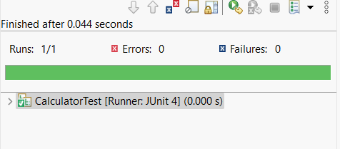

**Exercise 2: Assertions in Junit**

**AssertionsTest.java**

package test;

import static org.junit.Assert.*;

import org.junit.Test;

public class AssertionsTest {

@Test

public void testAssertions() {

assertEquals(5, 2 + 3);

assertTrue(5 > 3);

assertFalse(5 < 3);

assertNull(null);

assertNotNull(new Object());

}

}

Output:

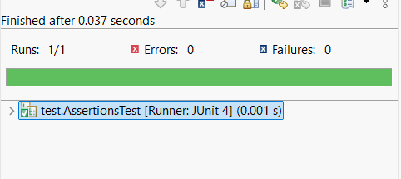

**Exercise 4: Arrange-Act-Assert, @Before, @After**

**FixtureTest.java:**

package test;

import static org.junit.Assert.*;

import org.junit.Before;

import org.junit.After;

import org.junit.Test;

public class FixtureTest {

private int value;

@Before

public void setUp() {

// Arrange

value = 10;

System.out.println("setup called");

}

@Test

public void testValue() {

// Act

int actual = value;

// Assert

assertEquals(10, actual);

}

@After

public void tearDown() {

value = 0;

System.out.println("teardown called");

}

}

**Output:**

